Creating a Microsoft Azure Pass Subscription

Creating an Azure Pass subscription is a two-step process.

1. Redeem your Azure Pass Promo Code
2. Activate your subscription

Step 1: Redeeming a Microsoft Azure Pass Promo Code:

* Open a browser and navigate to: [www.microsoftazurepass.com](https://www.microsoftazurepass.com/)

It is recommended you close all browsers and open a new In-Private Browser session. Other logins can persist and cause errors during the activation step.

* Click the start button to get started.

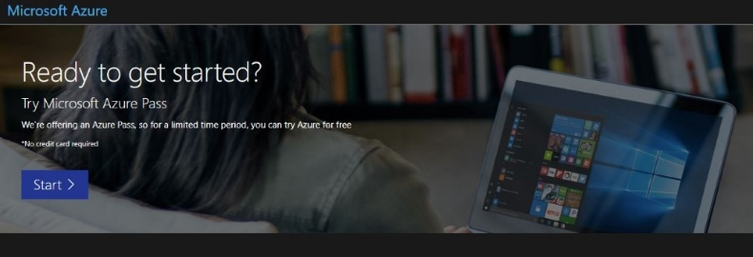

* Enter your account login information and select “Sign In”.

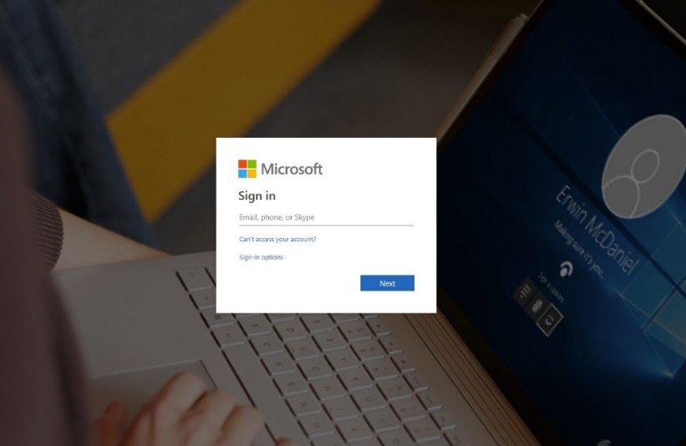

* Click “Confirm” if the correct email address is listed.

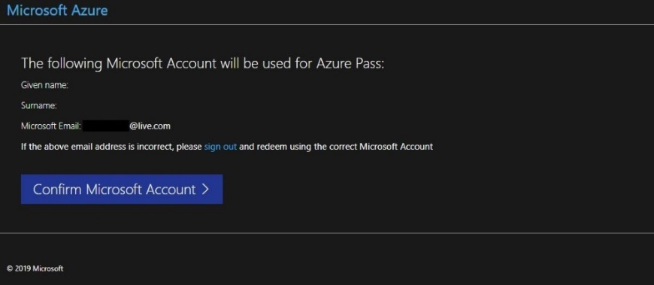

* Enter your promo code in the Promo code box and click “Claim Promo Code”.

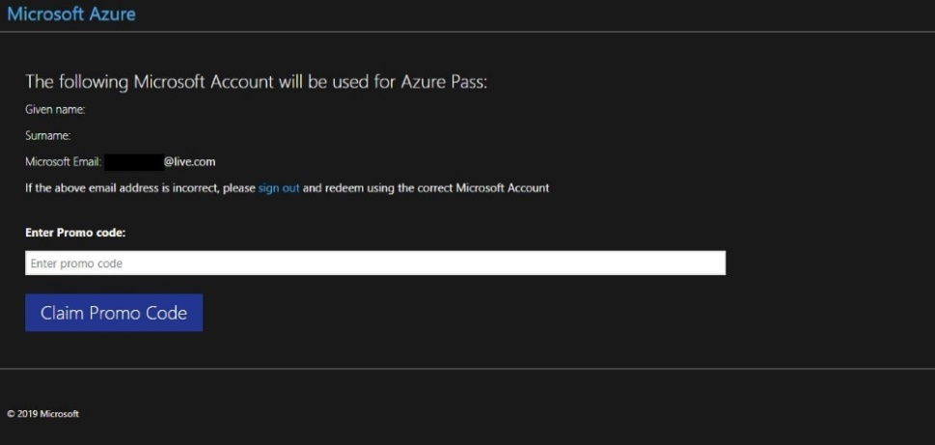

* It may take up to 5 minutes to process the redemption.

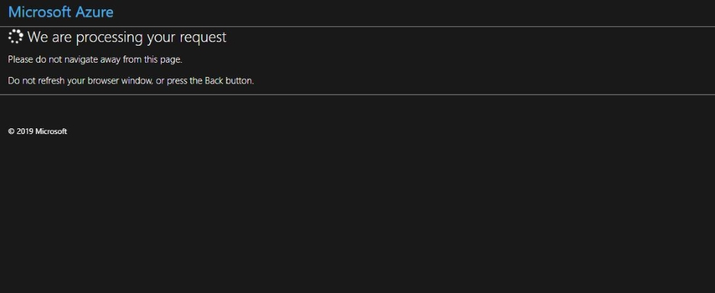

Step 2: Activate your subscription:

* When the redemption process is completed, it will redirect to the sign-up page.
* Enter your account information and click “Next”.

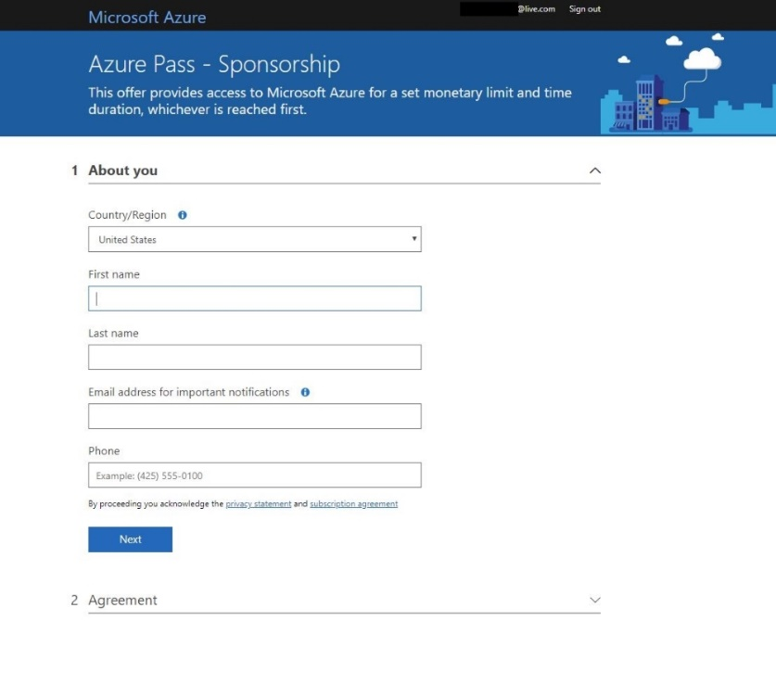

* Click the agreement check box and click the Sign-up button.
* It may take a few minutes to process the request.

* Your Azure subscription is ready

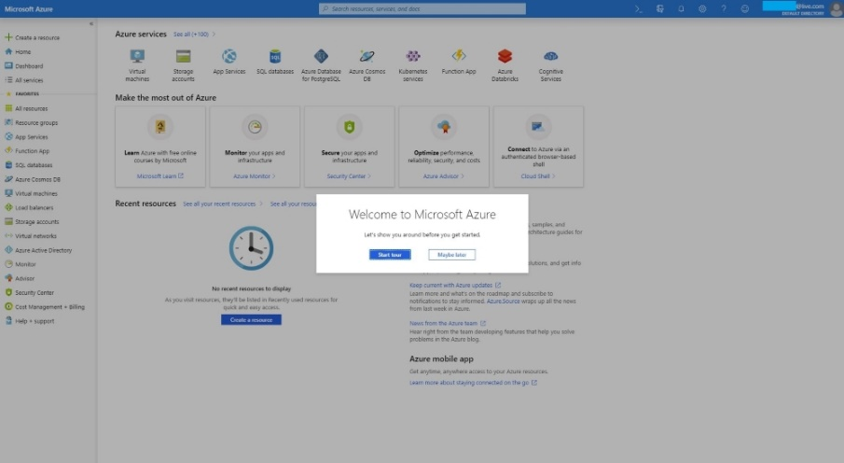

* You can check the balance of your Azure Pass Credits on <https://www.microsoftazuresponsorships.com/balance>

